Weekly report

EE 491 DEC1503
  - February 9, 2015

Modular Audio Mixer
  - Advisor: Josh Bertram
  - Client: Jay Becker
  - Clayton Hawken: Team Leader
  - Debbie Baeder: Team Communication Leader
  - Chad Stobbie: Team Concept Holder
  - Brian West: Team Webmaster

Weekly Summary
On Monday, the team met with our client over Google Hangouts to discuss conceptual questions, interests and background of the team members, and initial ideas. We now know that the design is ultimately up to us, and we can use Jay as the deciding factor on difficult decisions. Jay wants the mixer to be able to connect his multiple computers to one set of speakers. On Thursday, the team met with our advisor at Stomping Grounds. Josh let us know that he would be able to give us direction along the way if we got stuck on anything. He also wants to give us a few reference documents from Rockwell Collins for project planning and specifications. Brian started developing the website on Weebly.com. He plans to get more information onto the server as soon as possible.

Team/Client Meeting Notes
- Duration: 1 hour Members Present: Jay, Clay, Debbie, Brian, Chad
- Purpose and Goals: To ask Jay about his intentions, to inform him about who we are, and to brainstorm the initial concept design.
- Achievements:
  - Concept Ideas: Jay wants the mixer to be able to input multiple computer outputs, mix their audio signals individually, and output one signal to a set of speakers. He would like the mixer to use a shared bus, and be modular-ready for various potential functions. Jay informed the team that weight/size/power is not an issue, raspberry pi may be the better choice, Bluetooth capabilities should be considered, and the input levels should be independent.
  - Tentative Timeline: design by spring break, testing by dead week, and prototype by the end of the semester.
  - Brief Personality Profiles: Jay has worked with embedded systems, and has two degrees: Computer Engineering and Computer Science. Chad prefers to work with hardware, Debbie is interested in incorporating music technology, Clay is knowledgeable of signals and systems, and Brian wants to work with embedded systems.
  - Initial Thoughts: A quick block diagram of the concept is shown on the next page.
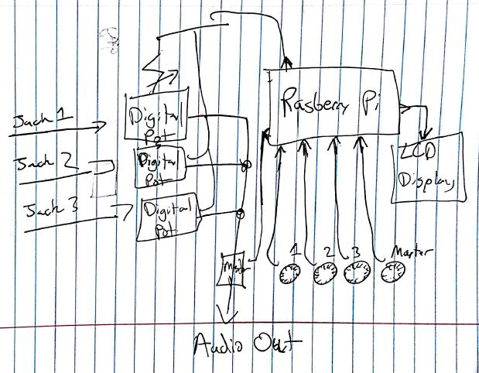

Team/Advisor Meeting Notes
- Duration: 1 hour Members Present: Josh, Clay, Debbie, Brian, Chad
- Purpose and Goals: To initialize the relationship between the team and the advisor, and define how we will work with each other.
- Achievements:
  - Josh’s Role: He wants to be able to use his knowledge and experience from working at Intel and Rockwell Collins to aid us along our process. He will be there to help us if we falter, and to keep us on track.
  - Career: We shared our major interests, and gave brief outlooks on our career goals. Josh wishes to help us on interviewing skills when it comes to answering questions on how we plan to deliver the product the client wants.
  - Project Outlook: Josh will send us a project planning document to help us define the parameters and specifications.

Pending Issues
- Our initial concept should develop parameters over the next couple weeks.
- The team needs to research concepts already developed.
- We need to get the website on the server.

Plans for Next Week
  - Brian: Develop website skeleton and deliver onto server.
  - All: Research and develop an understanding on I/O options, analog vs digital mixing methods, and raspberry pi functionality.

Individual Contributions
  - Clay: Kept contact with Jay and Josh for the meetings. Drew the initial concept.
  - Debbie: Recorded meeting notes. Documented the weekly report. Contributed to brainstorming the initial concept.
  - Brian: Started building the website. Contributed to brainstorming the initial concept.
  - Chad: Contributed to brainstorming the initial concept.

Weekly hours for the project: 12
Name | Hours
Clay Hawken | 3
Debbie Baeder | 4
Brian West | 3
Chad Stobbie | 2

total hours for the project: 25
Name | Hours
Clay Hawken | 7
Debbie Baeder | 8
Brian West | 5.5
Chad Stobbie | 4.5

